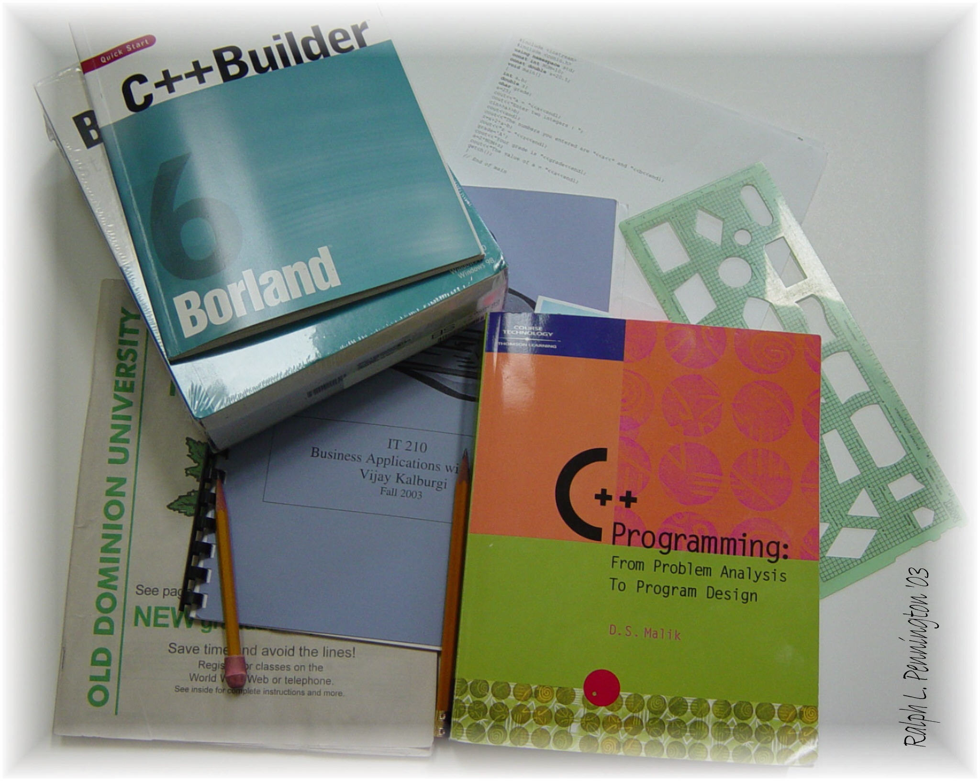

Michael Ragsdale
IT210 Business Applications with C++
TR 11:00 – 12:15 PM
Instructor: Vijay Kalburgi

Program Assignment 2

Average Daily Balance Calculator
Fall 2014

Michael Ragsdale

00978282

Average Daily Balance Calculator

October 9, 2014

